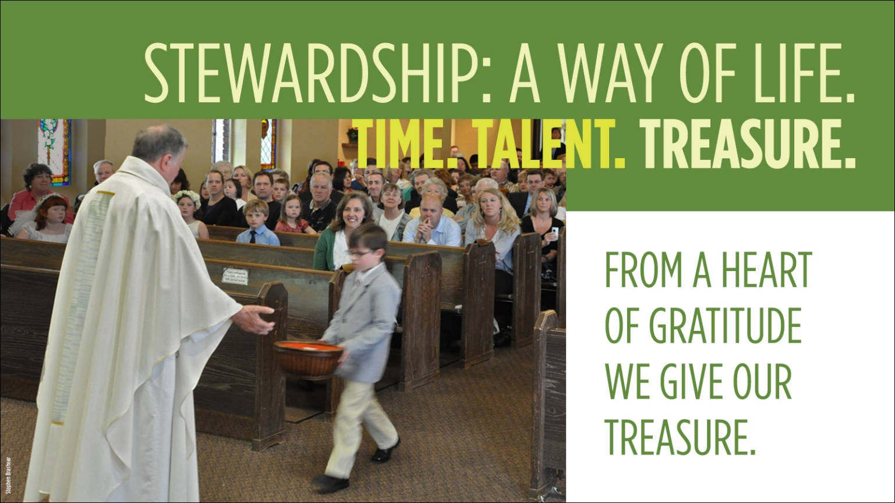
St. Theresa Parish provides this guide to help you plan your yearly giving.
Good Stewardship of Treasure Practices

Planned
A decision requiring thought & time so as not to give what is merely left at the end of a week.

Proportionate
Our giving is proportionate to what God has given to us. We give in proportion to the gifts we have received.

Sacrificial
We give back from our substance, rather than our abundance.

Grateful
Acknowledging that God is the source of all our gifts, we freely, without reservation or condition, give back to Him by sharing these gifts.

Online Giving
St. Theresa’s provides online giving for your convenience. Visit our website at http://www.sttheresafw.org and select the Online Giving button.

STEP 1: Determine yearly income.  = $  = $  = $  = $  My Income  Spouse Income  Other Income  Total Yearly Income | STEP 2: Determine % of income to give.  OR  Other %  10%  5%  I plan on giving:  2.5%
STEP 3: Calculate annual dollar amount to give.
Total Yearly Income (STEP 1) X Percentage to Give (STEP 2) = Total Yearly Giving Amount $________________
STEP 4: Determine the dollar amount for each giving opportunity.
 | Yearly Gift $
Church Offertory (goes directly to support your Parish)
Weekly $______________ X 52 Weeks OR Monthly $________________ X 12 Months
Holy Days: Solemnity of Mary (Jan 1), Easter, Ascension Thursday, Assumption (Aug 15), All Saints Day (Nov 1), All Souls Day (Nov 2), Immaculate Conception (Dec 8), Nativity
Annual Catholic Appeal (goes directly to support ministries and services of the Archdiocese)
Special/National Collections
NW Catholic (supports Archdiocese of Seattle Magazine)
PREPARES (supports pregnancy/parenting outreach)
Catholic Home Missions (supports Mission Dioceses in US)
CRS Rice Bowl (75% go to CRS/25% stays in W. Washington)
Catholic Relief Services (supports the World’s poor)
Peter’s Pence (Holy Father’s emergency relief fund for World’s most vulnerable)
Campaign for Human Development (addresses poverty in US)
World Mission Sunday (supports Mission Churches worldwide)
Catholic Community Services (serves the poor in W. Washington)
Disaster Relief/Other (Hurricane/Flood/Fire)
Extra Parish Ministry Donations
St. Vincent de Paul Society
Nontuition gift to Faith Formation
Other
World/Local/Community Charities
TOTAL YEARLY GIVING AMOUNT (matches amount from STEP 3) | 0

